FieldWorks
Translation Editor

Exercises



Copyright © 2005-2011 SIL International

Contents
Contents 2
Introduction 3
Module ED: Entering Draft Scripture 4
Exercise ED-1: Inserting a section 4
Exercise ED-2: Inserting verse numbers 5
Exercise ED-3: Inserting sections and numbers 6
Module BR: Backing Up and Restoring Projects 8
Exercise BR-1: Backing up and restoring projects 8
Module VN: Viewing and Navigating Data 9
Exercise VN-1: Viewing and navigating data 9
Module AS: Applying Styles 10
Exercise AS-1: Applying paragraph styles 10
Exercise AS-2: Applying character styles 11
Exercise AS-3: Applying character styles (limitation) 12
Exercise AS-4: Applying chapter and verse number styles 13
Exercise AS-5: Applying chapter and verse number styles 15
Module FT: Inserting Footnotes 16
Exercise FT-1: Inserting a general footnote 16
Module BT: Checking Back Translations 17
Exercise BT-1: Entering a back translation 17
Exercise BT-2: Marking paragraphs as finished 17
Exercise BT-3: Editing a translation and its back translation 18
Exercise BT-4: Marking paragraphs as consultant checked 20
Exercise BT-5: Multiple back translations 21
Exercise BT-6: Back translations of footnotes 22
Module IP: Importing Data 23
Exercise IP-1: Importing your Standard Format data 23
Module CM: Comparing and Merging Versions 24
Exercise CM-1: Comparing and merging versions of a book 24
Exercise CM-2: Comparing and merging versions of a book 25

Introduction
FieldWorks Translation Editor provides tools for editing and checking Scripture translations.
The goal of this training course is for you to be able to use Translation Editor to translate Scripture into a vernacular language. Each training module teaches one or more learning objectives. The learning objectives are things that most Bible translators need to be able to do.
In the course, you spend at least half of your time actually practicing the skills using realistic data. In each module in the Student Manual, follow the numbered steps and check your work using the screen shots. For more practice, do these exercises.

Opening course documents
The course includes the following documents: Student Manual, Exercises, Copy-and-paste Data, and Instructor Guide. To open a document (for example, Exercises), do either of the following:
- On the Help menu of Translation Editor, point to Training, and then click Exercises.
- In Windows Explorer, double-click the TE Exercises.doc file.
By default, it is installed in the following folder on 32-bit or 64-bit Windows, respectively:
C:\Program Files\SIL\FieldWorks 7\Translation Editor\Training
C:\Program Files (x86)\SIL\FieldWorks 7\Translation Editor\Training

Module ED: Entering Draft Scripture

Exercise ED-1: Inserting a section
To insert the section head and Scripture text of Matthew 1:18-25, do the following:
      - Make sure the insertion point is at the end of the last paragraph preceding the Kulambirwa kwa Misiya na anyakudziwisa section head.
      - On the Insert menu, click Scripture Section.
      - On the Help menu, point to Training, and then click Copy-and-paste Data.
      - In the TE Copy-and-paste Data.rtf file, move to Exercise ED-1: Inserting a section. Select the section head, and then press Ctrl+C to copy the text.
      - Switch to Translation Editor, click in the Type section head here area, and then press Ctrl+V to paste the text.
      - In the TE Copy-and-paste Data.rtf file, select the Scripture text, and then copy the text.
      - Switch to Translation Editor, click in the empty paragraph under the section head, and then paste the text.
      - If the insertion point is in an empty paragraph, press Backspace.
When you have finished, make sure that it is similar to the following screen shot.

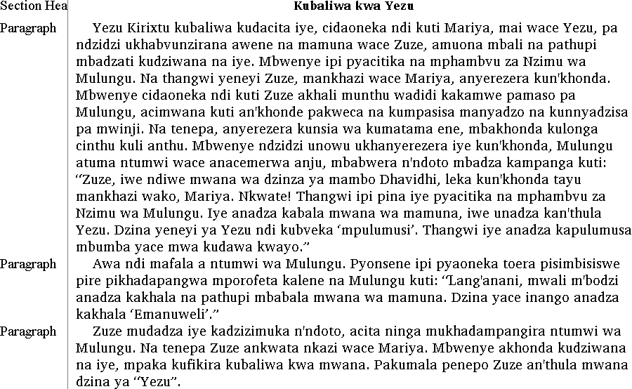

Exercise ED-2: Inserting verse numbers
If you did Exercise ED-1, you can insert verse numbers in Matthew 1:18-25.
      - Scroll to the Kubaliwa kwa Yezu section head.
      - Use your choice of methods to insert verse numbers as they appear in the following screen shot.

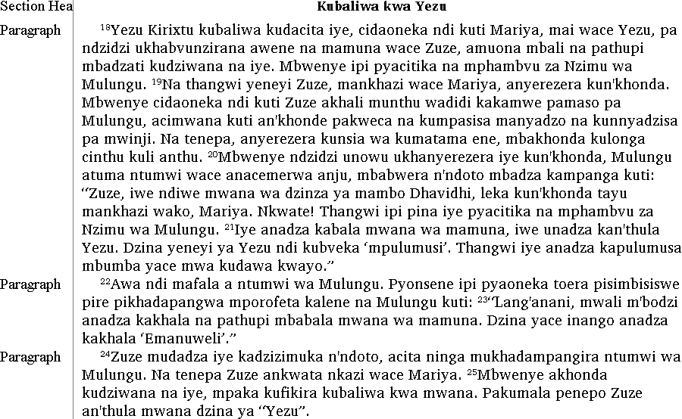

Exercise ED-3: Inserting sections and numbers
      - Insert the following four sections of Matthew 2:13–3:12. Before you insert each section, make sure the insertion point is at the end of the last paragraph of the preceding section. In the TE Copy-and-paste Data.rtf file, move to Exercise ED-3: Inserting sections and numbers.
- Matthew 2:13-15
- Matthew 2:16-18
- Matthew 2:19-23
- Matthew 3:1-12
      - Insert chapter number 3.
      - Insert the verse numbers as they appear in the screen shots on this page and the next page.
In chapter 2, verse numbers 19-20 are a verse bridge.

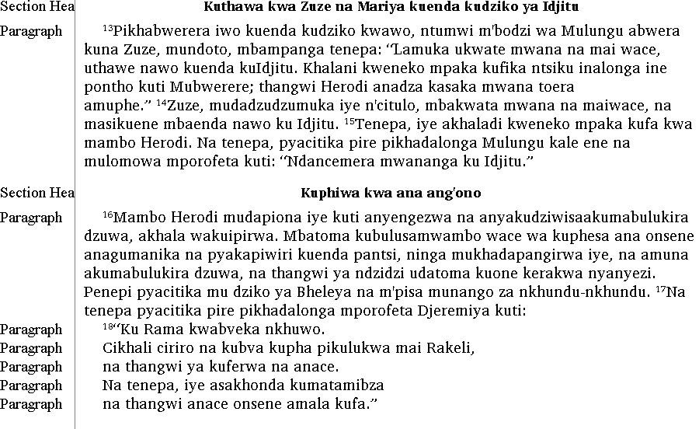

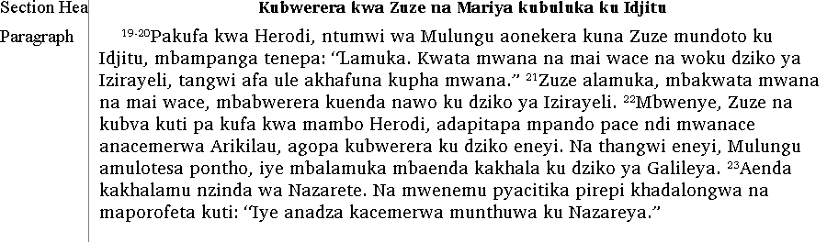

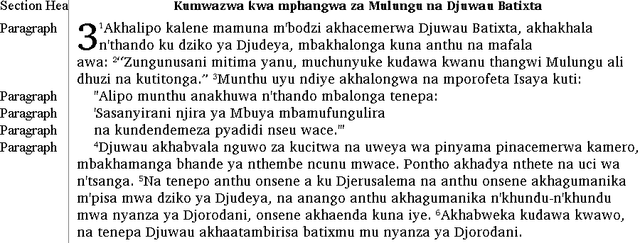

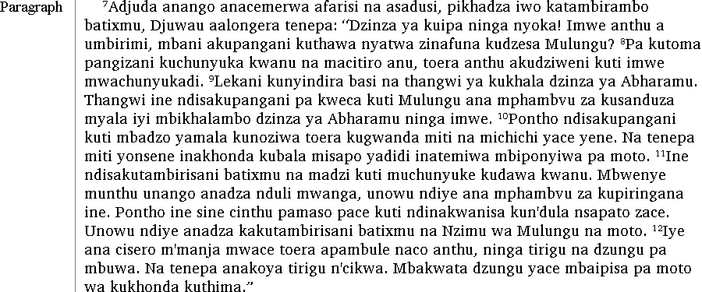

Module BR: Backing Up and Restoring Projects

Exercise BR-1: Backing up and restoring projects
As you work thorough this course, you may want to experiment with the Sena projects that were installed with FieldWorks. To be able to restore the original projects from backup files, do the following.
      - Open the Sena 3 project.
      - Back up the Sena 3 project.
In the Back up this Project dialog box, type Exercise BR-1 in the Comment area.
      - Close the Sena 3 - Translation Editor window.
      - If Sena 2 is not open, open the Sena 2 project.
      - Back up the Sena 2 project.
In the Back up this Project dialog box, type Exercise BR-1 in the Comment area.
      - Restore the Sena 2 project.
The Sena 2 - Translation Editor window closes and then opens with the restored project.

Module VN: Viewing and Navigating Data

Exercise VN-1: Viewing and navigating data
      - Go to Matthew 2:3.
      - Switch to Scripture Print Layout view.
      - Turn on Full Window view.
      - Go to Matthew 3:1.
      - Turn off Full Window view.
      - Switch to Scripture Draft view.
      - Go to Matthew 1:1.

Module AS: Applying Styles

Exercise AS-1: Applying paragraph styles
      - Select all the paragraphs in Matthew 1:7-16.
      - Apply List Item2 paragraph style.
      - Select the first line of Matthew 1:12.
      - Apply List Item1 paragraph style.
When you have finished, make sure that it is similar to the following screen shot.

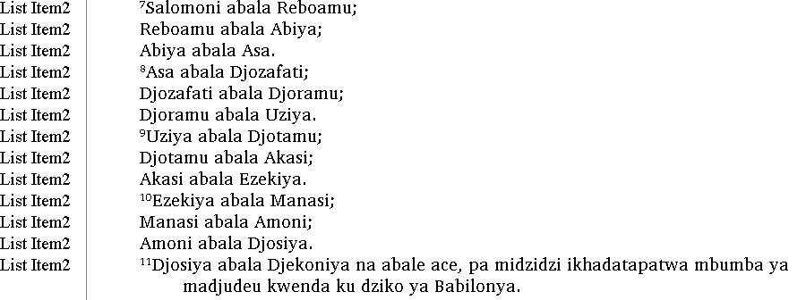

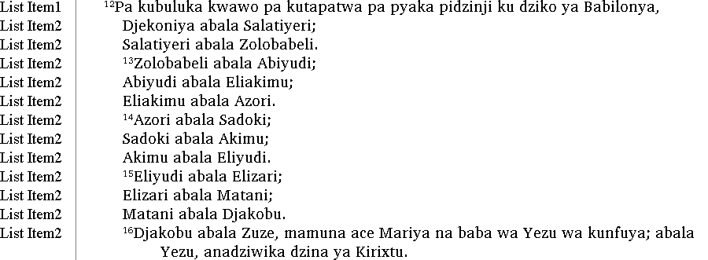

Exercise AS-2: Applying character styles
- Apply Quoted Text character style to the following three quoted phrases.
Reference | Selected text
Matthew 4:4 | ‘Munthu nkhabe kukhala m'maso basi na kudya mikate yokha, mbwenye na kubvambo mafala onsene a Mulungu.’
Matthew 4:7 | ‘Leka kulesera Mbuya Mulungu wako.’
Matthew 4:10 | ‘Godamira na kulambira Mbuya Mulungu wako ekha basi.’

When you have finished, make sure that it is similar to the following screen shot.

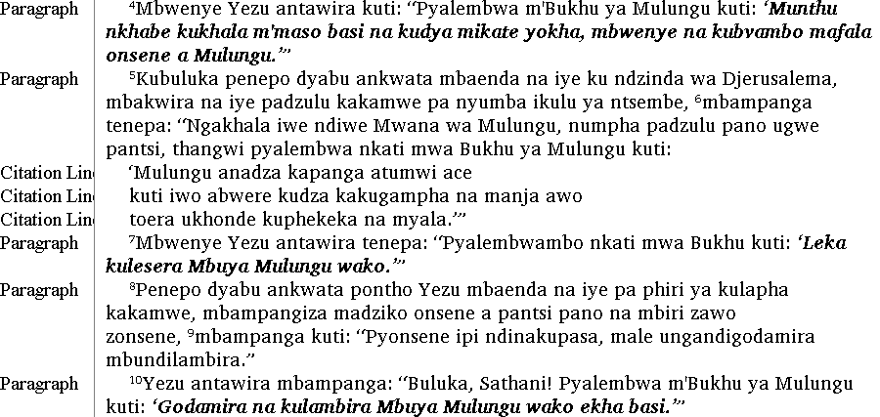

Exercise AS-3: Applying character styles (limitation)
Some people format the words of Christ in red. In Matthew 4, verses 4, 7, and 10 contain words of Christ which consist partly of quoted text. In Translation Editor, you can apply only one character style to selected text. Given the limitation in Translation Editor, you might decide to apply Words of Christ style first, and then apply Quoted Text style.
      - Apply Words Of Christ character style to the following selected text. Notice that it removes Quoted Text character style.
Reference | Selected text
Matthew 4:4 | “Pyalembwa m'Bukhu ya Mulungu kuti: ‘Munthu nkhabe kukhala m'maso basi na kudya mikate yokha, mbwenye na kubvambo mafala onsene a Mulungu.’”
Matthew 4:7 | “Pyalembwambo nkati mwa Bukhu kuti: ‘Leka kulesera Mbuya Mulungu wako.’”
Matthew 4:10 | “Buluka, Sathani! Pyalembwa m'Bukhu ya Mulungu kuti: ‘Godamira na kulambira Mbuya Mulungu wako ekha basi.’”

      - Do Exercise AS-2 again. Notice that the end quote marks still have Words of Christ style.
When you have finished, make sure that it is similar to the following screen shot.

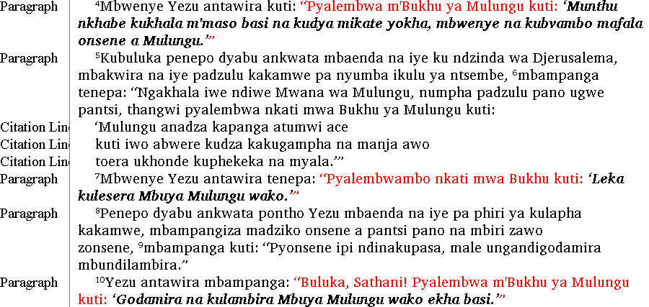

Exercise AS-4: Applying chapter and verse number styles
      - Insert the following five sections of Matthew 13:24-43. Before you insert a section, make sure the insertion point is at the end of the last paragraph of the preceding section.
If you forget how to insert a Scripture section, see Exercise ED-1.
In the TE Copy-and-paste Data.rtf file, move to Exercise AS-4: Applying chapter and verse number styles.
- Matthew 13:24-30
- Matthew 13:31-32
- Matthew 13:33
- Matthew 13:34-35
- Matthew 13:36-43
      - At the beginning of the text, select 13, and then apply Chapter Number character style.
      - Select each verse number in the text, and then apply Verse Number character style.
      - In Matthew 13:35, do the following:
- Apply Citation Line1 paragraph style to “Ndinadza kalonga na misanje,
- Apply Citation Line2 paragraph style to mbadilongera pinthu pikhadabisala kutomera pa kutoma kwa dziko. ”
- Apply Quoted Text character style to the text of both lines.
When you have finished, make sure that it is similar to the screen shot on the next page.

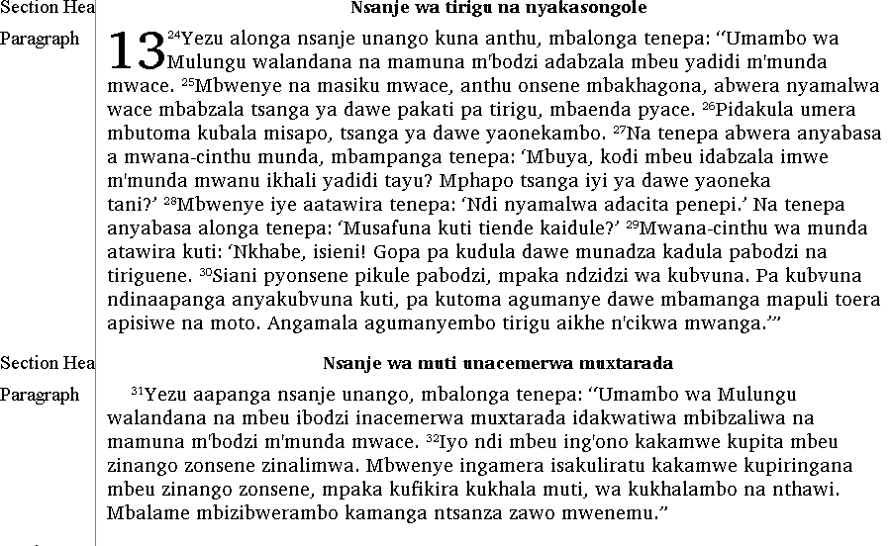

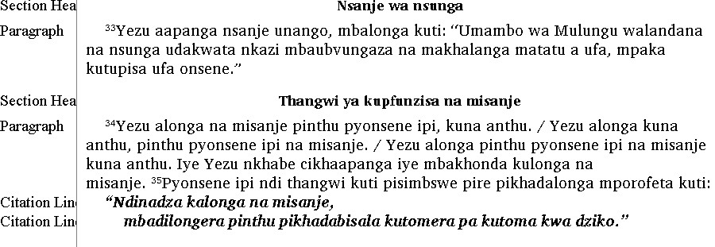

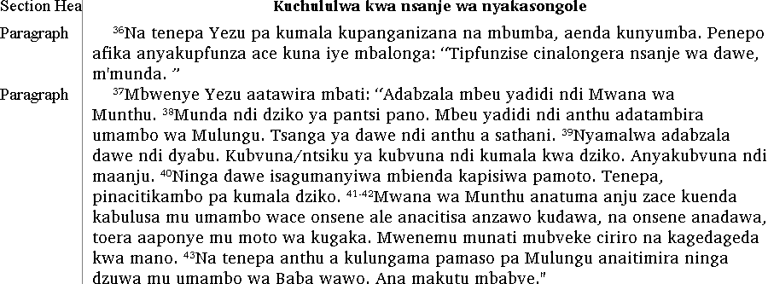

Exercise AS-5: Applying chapter and verse number styles
      - In the TE Copy-and-paste Data.rtf file, go to Exercise AS-5: Applying chapter and verse number styles. Insert Matthew 21:28-32 into the project.
Matthew 21:33-45 already exists in the project. Delete the previous chapter 21 number.
      - At the beginning of the text, select 21, and then apply Chapter Number character style.
      - Select each verse number in the text, and then apply Verse Number character style.
When you have finished, make sure that it is similar to the following screen shot.

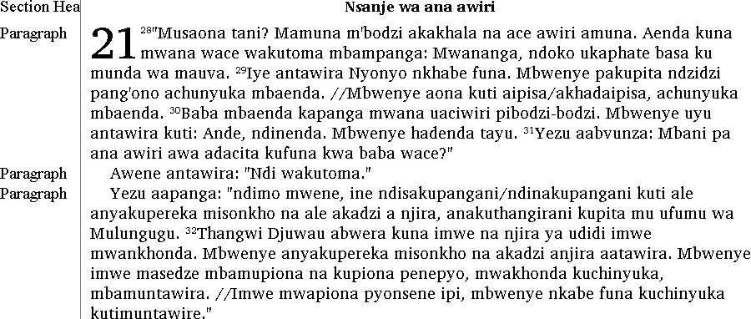

Module FT: Inserting Footnotes

Exercise FT-1: Inserting a general footnote
      - Insert a general footnote at the end of Matthew 16:3.
      - Paste the same footnote text that you copied from the TE Copy-and-paste Data.rtf file.
When you have finished, make sure that it is similar to the following screen shot.

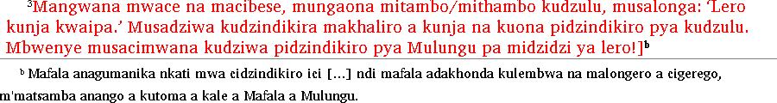

      - Insert a general footnote at the end of Matthew 21:44.
      - Paste the same footnote text that you copied from the TE Copy-and-paste Data.rtf file.
When you have finished, make sure that it is similar to the following screen shot.

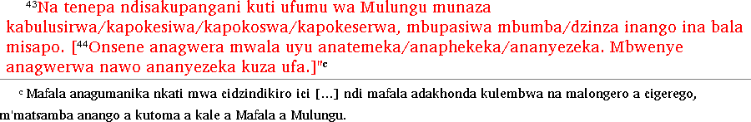

Module BT: Checking Back Translations

Exercise BT-1: Entering a back translation
- Enter the Portuguese back translation of Matthew 2:13-15. In the TE Copy-and-paste Data.rtf file, move to Exercise BT-1: Entering a back translation.
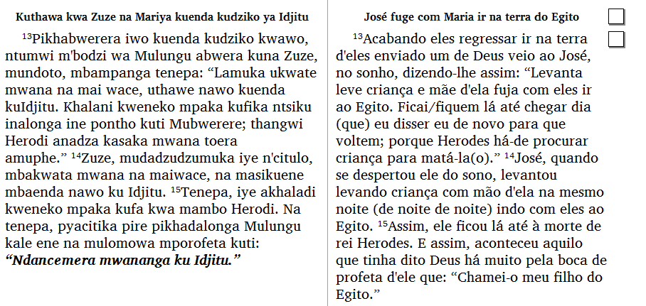
When you have finished, make sure that it is similar to the following screen shot.

Exercise BT-2: Marking paragraphs as finished
- Change the status of Matthew 2:13-15 from unfinished to finished.
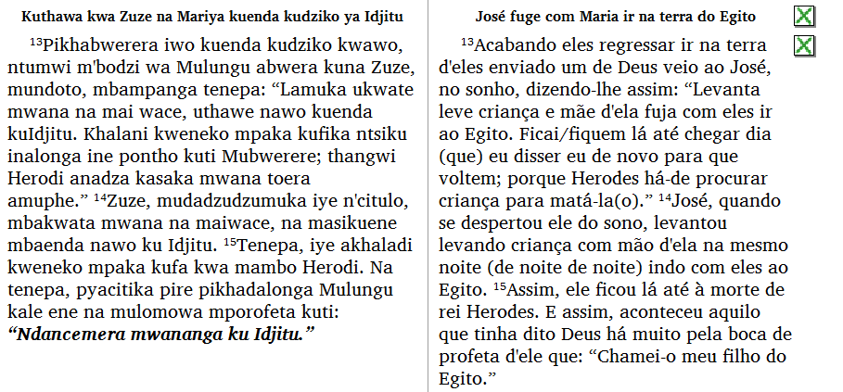
When you have finished, make sure that it is similar to the following screen shot.

Exercise BT-3: Editing a translation and its back translation
Edit the Sena translation and Portuguese back translation of Matthew 2:16-18.

Editing a vernacular translation
      - Go to Matthew 2:16 in the Sena translation.
      - In verse 16:
        - At the end of the first sentence, change wakuipirwa to wa kuipirwa maningi.
        - At the end of the second sentence, change nyenyezi to kwa nyanyezi.
        - In the third sentence, change pinango pya to munango za.
      - In verse 17 between pikhadalonga and mporofeta, insert two words: Mulungu na.
      - In verse 18, edit two of the five paragraphs:
        - In the second paragraph, change pikulukwa to pikulu kwa.
        - In the fourth paragraph, delete iye.
        - In the fourth paragraph, change kumatamiswa to kumatamibza.
When you have finished, make sure that it is similar to the following screen shot.

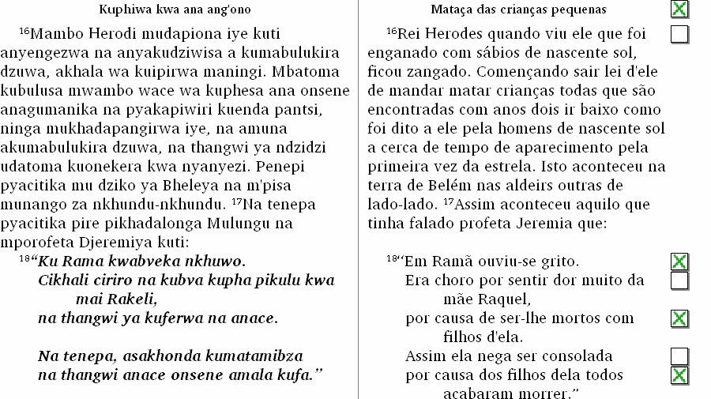

Editing a back translation
      - Go to Matthew 2:16 in the Portuguese back translation.
      - In verse 16 between ficou and zangado, insert the word muito.
      - In verse 17 between falado and profeta, insert two words: Deus atraves.
      - In the fourth paragraph in verse 18 between Assim and nega, delete ela.
Make sure not to delete d'ela in the third paragraph.
      - At the right of the following paragraphs, click the check box in the back translation pane:
- Matthew 2:16-17
- The second paragraph of Matthew 2:18
- The fourth paragraph of Matthew 2:18
When you have finished, make sure that it is similar to the following screen shot.

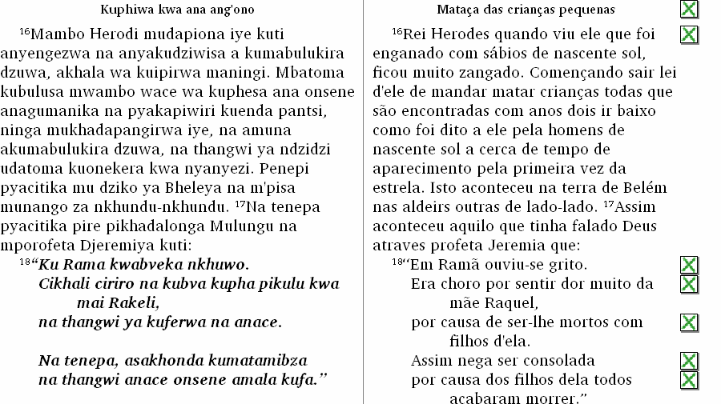

Exercise BT-4: Marking paragraphs as consultant checked
- Change the status of Matthew 2:13-15 from finished to consultant checked.
When you have finished, make sure that it is similar to the following screen shot.

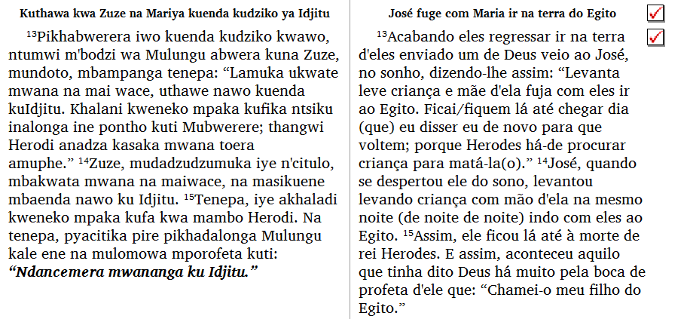

Exercise BT-5: Multiple back translations
- Enter the English back translation of Jonah 4:6-11. In the TE Copy-and-paste Data.rtf file, move to Exercise BT-5: Multiple back translations. Mark the paragraphs as finished.
When you have finished, make sure that it is similar to the following screen shot.

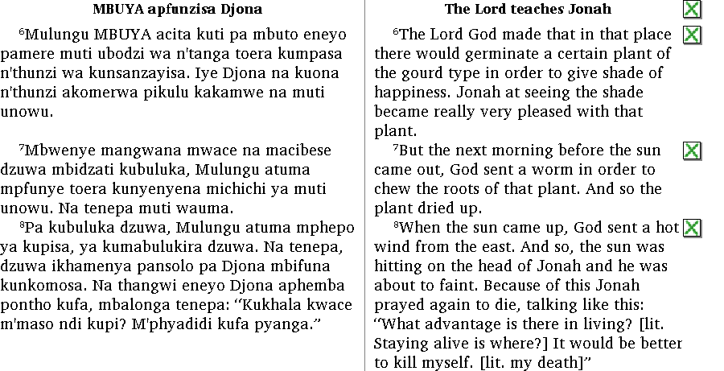

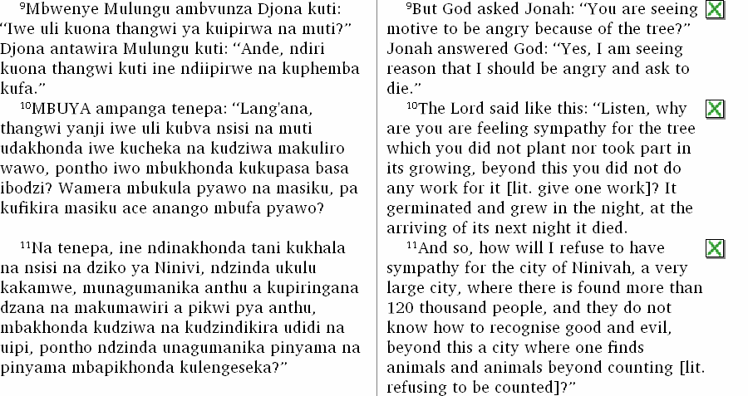

Exercise BT-6: Back translations of footnotes
If you have inserted the footnotes in Exercise FT-1, you can enter their back translations.
      - Insert a general footnote marker at the end of the Portuguese back translation of Matthew 16:3.
      - Paste the same Portuguese back translation that you copied from the TE Copy-and-paste Data.rtf file.
When you have finished, make sure that it is similar to the following screen shot.

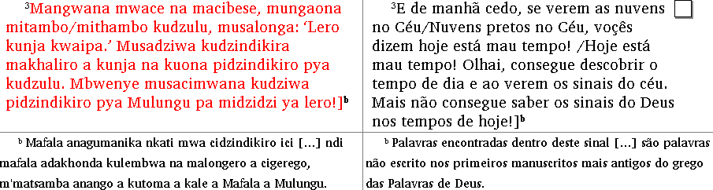

      - Insert a general footnote marker at the end of the Portuguese back translation of Matthew 21:44.
      - Paste the same Portuguese back translation that you copied from the TE Copy-and-paste Data.rtf file.
When you have finished, make sure that it is similar to the following screen shot.

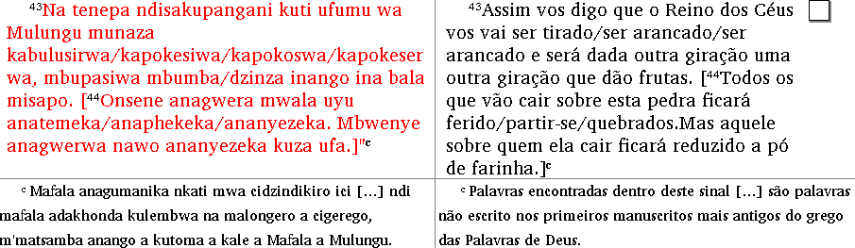

Module IP: Importing Data

Exercise IP-1: Importing your Standard Format data
If you do not need to import data into your own FieldWorks project, you can skip this exercise.
As practice in a real situation from your own work, you can do the following:
      - Create your FieldWorks project (in the Student Manual, see Module SU).
      - Insert a book that you plan to import, but only type the book title (see Module ED).
      - Back up your FieldWorks project (see Module BR).
      - Import your data (see Module IP).

Tip: We recommend that you import your data one book at a time. Examine the imported data in Translation Editor to make sure it was imported correctly. If there are problems, restore your project from a backup file to its state before importing. You might need to customize the options in the import process. You might also need to make some consistent changes to the format of the data in the files. If possible, ask your local computer support person to assist you. Make sure the data is imported correctly before you edit the data in Translation Editor.

Module CM: Comparing and Merging Versions

Exercise CM-1: Comparing and merging versions of a book

Saving a version of a book
- Save a version of Matthew. In the Description box, type Before I did Exercise CM-1

Editing a translation
Edit the vernacular translation of Matthew 6:22-23.
      - Go to Matthew 6:22.
      - In verse 22:
        - In the first sentence, change Maso ndi cedza ca manungo to Ceza ca manungo ndi maso.
        - At the end of the second sentence, change manungo ako onsene ali mucedza to thupi yako yonsene ali muceza.
      - Almost at the end of verse 23, insert the two words nkhulongera kuti preceding cidima ceneci nchikulu kakamwe.
When you have finished, make sure that it is similar to the following screen shot.

Comparing and merging versions of a book
- Compare the current version of Matthew to the Before I did Exercise CM-1 version.
- To keep the Review Committee’s changes, click Keep Current two times.
When you have finished, make sure that it is similar to the following screen shot.

Exercise CM-2: Comparing and merging versions of a book

Saving a version of a book
- Save a version of Matthew. In the Description box, type Before I did Exercise CM-2

Editing a translation
Edit the vernacular translation of Matthew 6:24-34.
      - Go to Matthew 6:24
      - In verse 24:
        - In the first sentence, change azungu to ambuya.
        - In the second sentence, change ene to pabodzi.
      - In the second sentence in verse 25:
        - In the middle of the sentence, change kulalama kwanu to makhaliro a manungo ano.
        - At the end of the sentence, change kulalama kwanu to makhaliro anu.
      - In the third sentence in verse 26, change ali kuwapasa to asaapasa.
When you have finished, make sure that it is similar to the following screen shot.

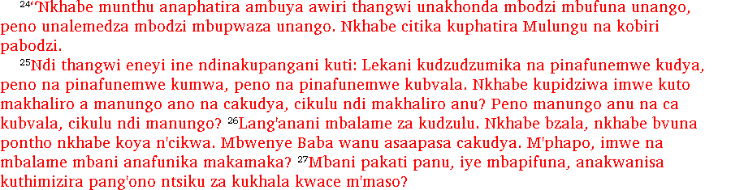

Comparing and merging versions of a book
- Compare the current version of Matthew to the Before I did Exercise CM-2 version.
- For the first change, click Keep Current.
- For the second change, click Use This Version.
- For the third change, click Keep Current.
When you have finished, make sure that it is similar to the following screen shot.

